Lab: Unit 01 – Introduction

# Overview

In this lab we will learn how to install, configure and access the database management system and its supporting tools.

## Learning Objectives

Upon completion of the lab, you should be able to:

* Use docker to start, stop, and troubleshoot the lab environment.
* Write queries using Azure Data Studio and SQLPad.
* Use the database provisioner to setup initial databases and add data.
* Connect to the Microsoft SQL Server DBMS using Azure Data Studio, SQLPad and Adminer.

## About the Lab Environment

There are several challenges to learning databases on a real database management system.

* You must go through the steps of installing the DBMS. Not something that is done every day.
* You have administrative access to the system and can easily screw things up.
* You have no sample databases to work from.
* Since you are learning, you might accidentally delete or update the data.

The lab environment I’ve created for you eliminates these problems. If you mess things up, you c an reset everything back to the way it was. It uses consistent tooling which will work on Windows, Mac, Linux and even a Chromebook. Sample databases are included, and you can install /install them easily.

## How is this possible?

The lab environment uses docker <https://docker.com> to run the database management system and supporting applications in containers. Containers are virtualized applications which are pre-configured for you and can be turned on and off easily.

This repository contains docker configurations and base scripts necessary to provide a complete database management system with sample data and web-based tooling.

Use this software to accompany the Applied Database Management textbook, the Introduction to Database Management Systems course, or to just explore databases on your own!

## What’s included?

1. Microsoft SQL Server 2017 database management system.   
   <https://www.microsoft.com/en-us/sql-server/sql-server-2017>
2. SQL Pad a web-based query tool.   
   <https://rickbergfalk.github.io/sqlpad>
3. Adminer a web-based database admin tool.   
   <https://www.adminer.org/>
4. Database Provisioner Application for creating sample databases and populating data.

# Install it or Use it?

One decision you are going to have to make very early on is whether or not to install the lab environment on your own computer or just use the environment set up for you on the iSchool’s vlab. Besides the comfort of using your own computer, the advantage of installing it on your own hardware is that when the semester is over you can still access the database environment and all of your projects . If you run it from the hosted iSchool vlab everything will be set up for you, but you will not be able to access it when the semester is over. Everything is setup for you on vlab but since you are accessing another computer over the internet it will be slower than if you installed everything yourself.

We will walk you through both so that you can make a more educated decision.

## Use It: Vlab

The ischool virtual lab is accessible at <https://vlab.ischool.syr.edu>. If you are currently enrolled in IST659 you should have an account on this server and be able to access the lab environment in a Linux virtual machine.

Log into vlab with your net ID and password.

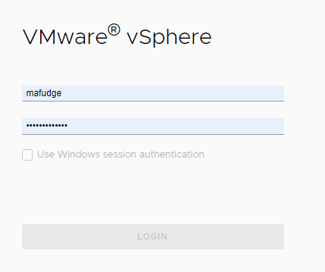

After you login You should see a folder labeled IST659. within that folder you should find a folder with your NetID, and within that folder you will see your virtual machine:

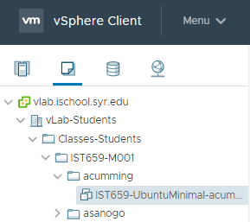

Use the actions menu to power on your virtual machine and then launch the web console.   
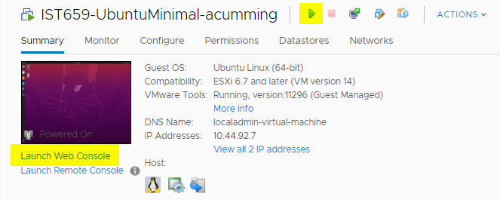  
You should see a login screen where you can Log in as user **localadmin** with password **SU44orange!** And from there you will be taken to the Ubuntu linux desktop.

To access the lab environment from here, first launch the terminal:  
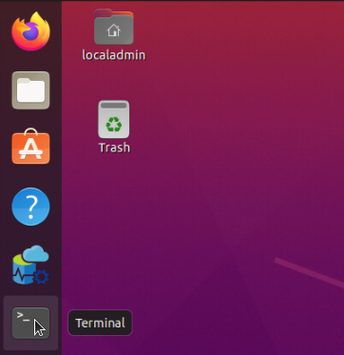

Then from within the terminal type:  
**cd learn-databases**and press ENTER to access the lab folder.

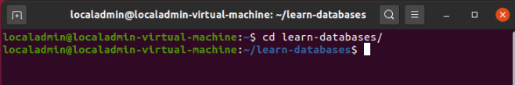

If your prompt looks like screenshot above, you are in the proper folder. Whenever you are asked to **open a command prompt in the learn-databases folder** you should follow these instructions.

## Install It: Your own computer

These instructions will guide you through an installation of the learn databases lab environment on your personal computer.

### Hardware Requirements for Install

1. A computer with one of these Operating Systems:
   1. Mac OSX
   2. Windows 10  
      <https://support.microsoft.com/en-us/help/13443/windows-which-version-am-i-running>
   3. Any Linux (Ubunutu, Fedora, etc. ) or
   4. Chrome OS w/Linux support enabled  
      <https://support.google.com/chromebook/answer/9145439?hl=en>
2. At least 8 GB RAM.
3. At least 8 GB free disk space.

The RAM and free disk space are soft requirements. You can get away with 4 GB RAM and 2GB free disk space, but 8/8 are recommended for best performance.

### Software Requirements for Install

You will need to install some pre-requisite free software on your computer:

1. Docker is required to manage the containers. Installation instructions are here: <https://docs.docker.com/get-docker/>
2. You must allocate at least 1CPU and 4GB of RAM to docker.
   1. Mac: <https://docs.docker.com/docker-for-mac/#resources>
   2. Windows: No configuration Necessary with WSL setup.
   3. Linux/ChromeOS: No Configuration Necessary, but you will need to install docker-compose separately.
3. Azure Data Studio. This is the client tool used to connect to the Microsoft SQL Server and compliments the web equivalents of SQL Pad and Adminer.

<https://docs.microsoft.com/en-us/sql/azure-data-studio/download-azure-data-studio>

### Installing Learn Databases

To install Learn Databases, clone or download this repository to your computer.

If you have git installed on your computer and wish to clone the repository:

1. Open a terminal window. Make sure you are in a folder where you wish to store the code repository.
2. Type: git clone <https://github.com/mafudge/learn-databases.git>   
   and press ENTER.  
   The code will download from github to your computer.

If you do not have git installed or you do not wish to clone the repository:

1. Click <https://github.com/mafudge/learn-databases/archive/master.zip> to download this repository.
2. After it downloads, unzip the file to a folder where you wish to store the code repository.

Open a terminal in the folder where you installed learn databases and you are ready to go.

# Walkthrough

This video demonstrates how to start, stop and debug the docker environment and connect to Microsoft SQL Server through the Azure Data Studio, SQLPad and Adminer.

# [Learn Databases Walkthrough](https://www.youtube.com/embed/CxCUrQ6knRo?feature=oembed)

# Screen Shots 101

You will be asked to turn in screen shots along with your code as part of problem set submissions. Whenever prompted to provide a screenshot, you **must** include your NetID within the screenshot.

## Including Your NetID

For screen grabs, the easiest way to do this is open notepad or some other text editor, type in your NetID, and make sure that window is captured with the screenshot.

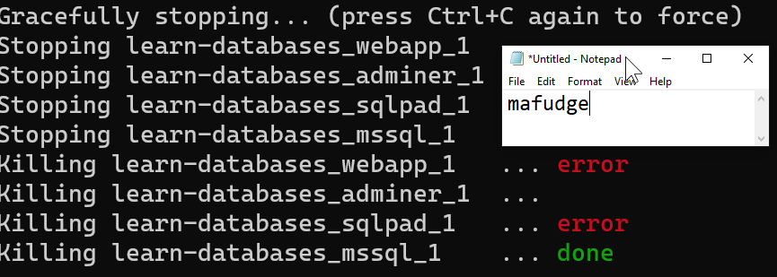

Figure 1 Sample screenshot with NetID displayed in notepad included

## Screen Shots of Code You have Executed

When taking a screenshot of code, it is not necessary to include notepad. Instead just type your NetID as a code comment:

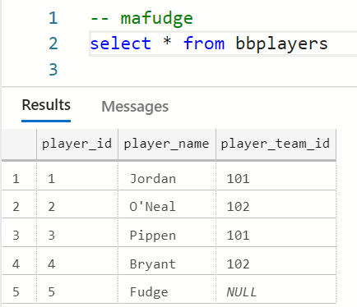

Figure 2 Sample screenshot with NetID in the code comments

Code screenshots should **always** include evidence the code was executed (including the Results pane is sufficient) and include the text version of the code in addition to the screenshot.

## Be a Minimalist!

Do not include more screen in your screenshot than is necessary. Make sure your screenshot is legible. The best way to do this is to avoid full screen shots and instead focusing on only what matters. Most screen shot utilities allow you to grab a region of the screen. Use that feature. For example, this is the full screen version of the previous screenshot. This screenshot is not very useful!

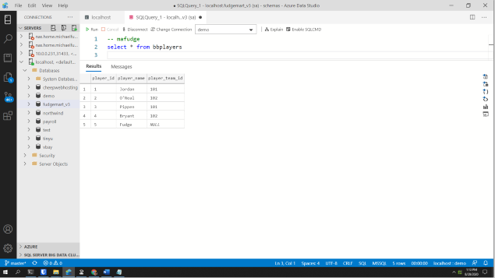

Figure 3A not very useful screenshot - because it’s the entire screen.

# Questions

Answer these questions using the problem set submission template.

1. Use docker-compose to start the containers. What is the command you typed to do this?

**docker-compose up -d**

1. What is the command to show the running docker containers?

**docker-compose ps**

1. Provide a screenshot displaying evidence your containers are running (the output of the previous question should suffice).

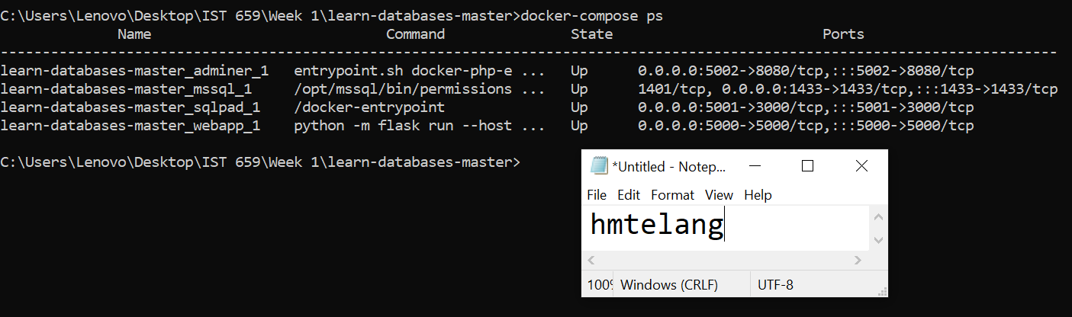

1. Provision all the databases included in the Database provisioner application. Provide a screenshot as evidence they have been provisioned. Note: This might take some time so be patient!

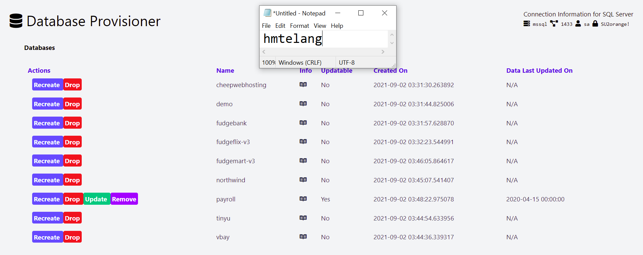

1. Connect to MS SQL Server using azure data studio and provide a screenshot of the databases under the connection. This will provide evidence your connection works and your databases were provisioned.

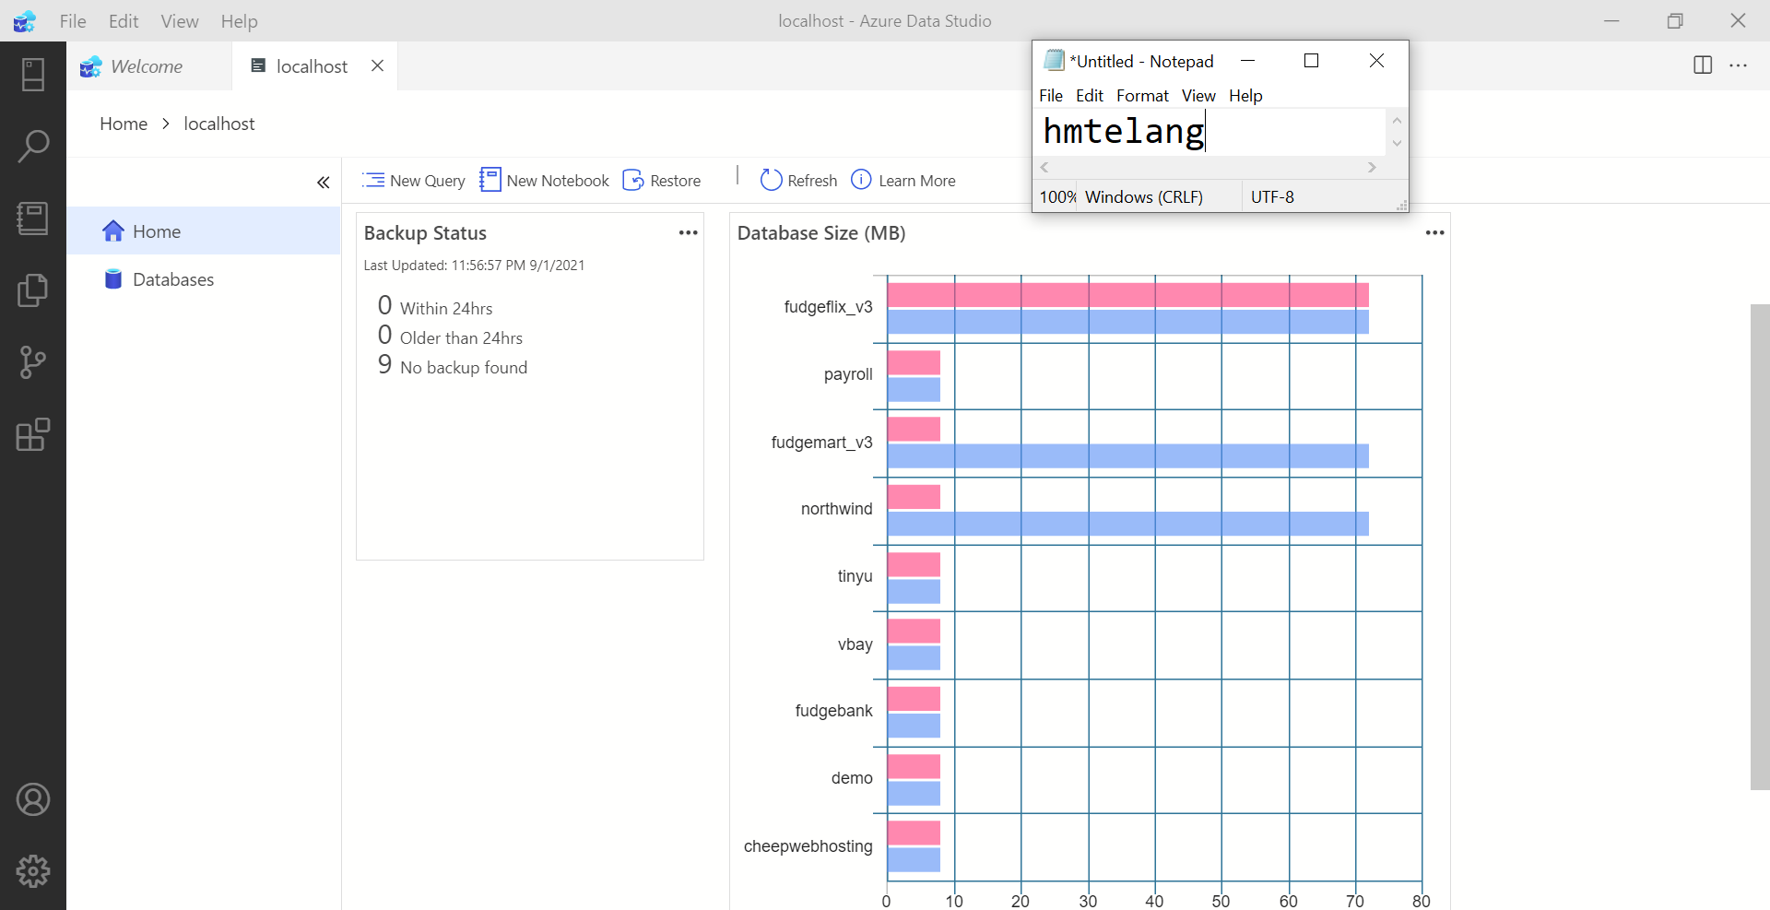

1. Connect to MS SQL server using SQL Pad. Specifically connect to the **payroll** database and then run this query: select * from department_lookup  
   Include a screenshot of the query and output.

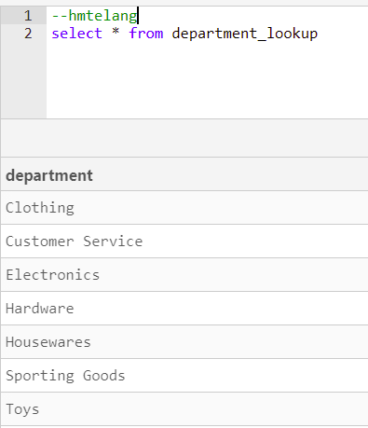

1. Connect to MS SQL server using Adminer, again connect to the **payroll** database. Include a screenshot of the structure of the **employees** table.

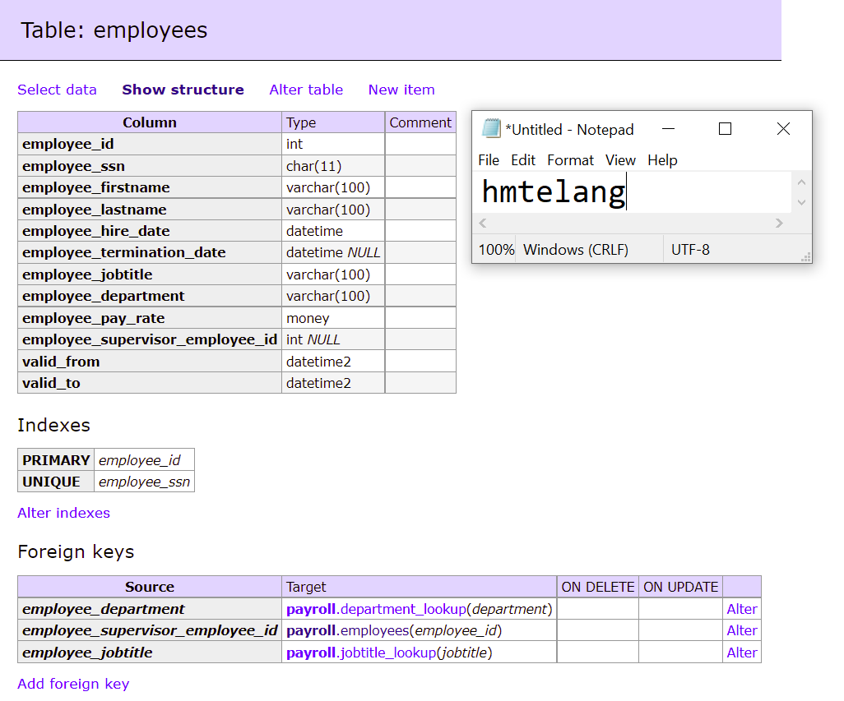

1. What is the command to shut down the running docker containers?

**docker-compose down**

1. Provide a screenshot displaying evidence your containers are no longer running (the output of the previous question should suffice).

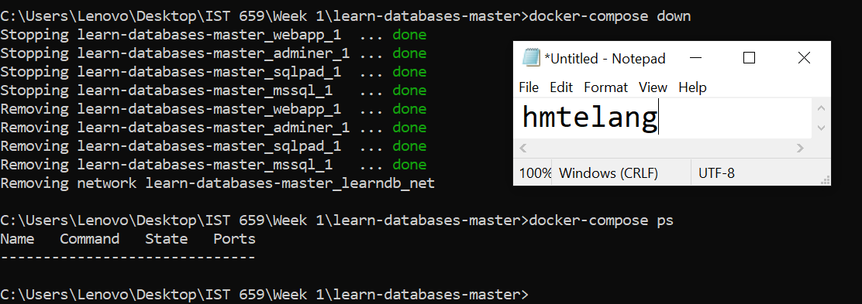

# Reflection

Use this section to reflect on your learning. To achieve the highest grade on the assignment you must be as descriptive and personal as possible with your reflection.

1. What are the key things you learned through the process of completing this assignment?
2. What were the challenges or roadblocks (if any) you encountered on the way to completing it?
3. Were you prepared for this assignment? What can you do to be better prepared?
4. Now that you have completed the assignment rate your comfort level with this week’s material. This should be an honest assessment: (choose one)  
     
   4 ==> I understand this material and can explain it to others.  
   3 ==> I understand this material.  
   2 ==> I somewhat understand the material but sometimes need guidance from others.  
   1 ==> I understand very little of this material and need extra help.